VIGENERE:
The following was the challenge:

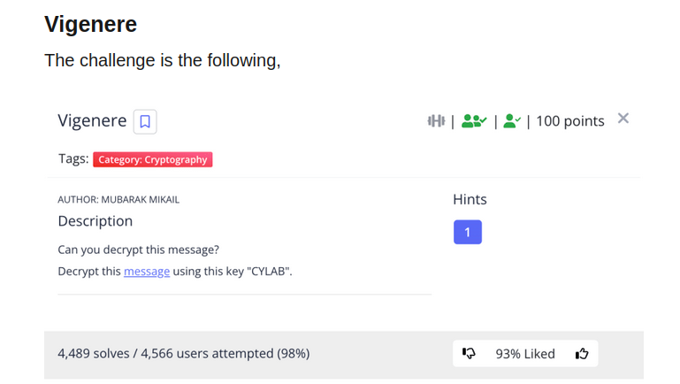

This was the flag format given in the message:

rgnoDVD{O0NU_WQ3_G1G3O3T3_A1AH3S_2951c89f}

Using CyberChef I then decoded the flag given in vigenere cipher with the key being CYLAB

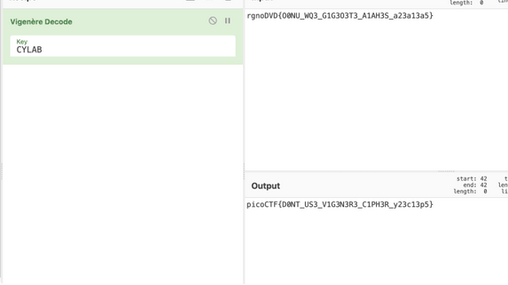

The final flag was:

picoCTF{D0NT_US3_VIG3N3R3_CIPH3R_y23c13p5}

